

Actividad [#2] – [Relationships and Segments] [Ingles para los negocios]

Ingeniería en Desarrollo de Software

**Tutor: Fátima Fernández de Lara Barrón**

**Alumno: Manuel Enrique Ramirez Lopez**

**Fecha: 18/05/2022**

***Indice***

*Developing* 1

*Screenshots* 3

*Conclusion* 4

*Bibliography* 5

# *Developing*

**Context:**

For this second activity, you will describe the following three components: Value proposition, Customer relationships and Customer segments. You must write at least 100 words to describe each one. After that, you must write a conclusion to explain how those components interact to each other. The conclusion must be at least 100 words

-We will select and use our canvas template

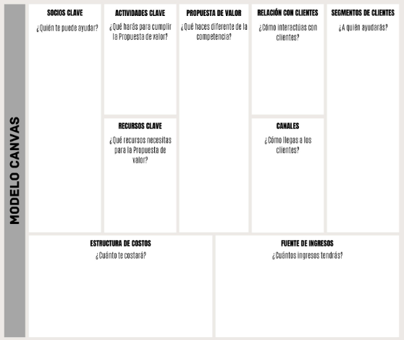

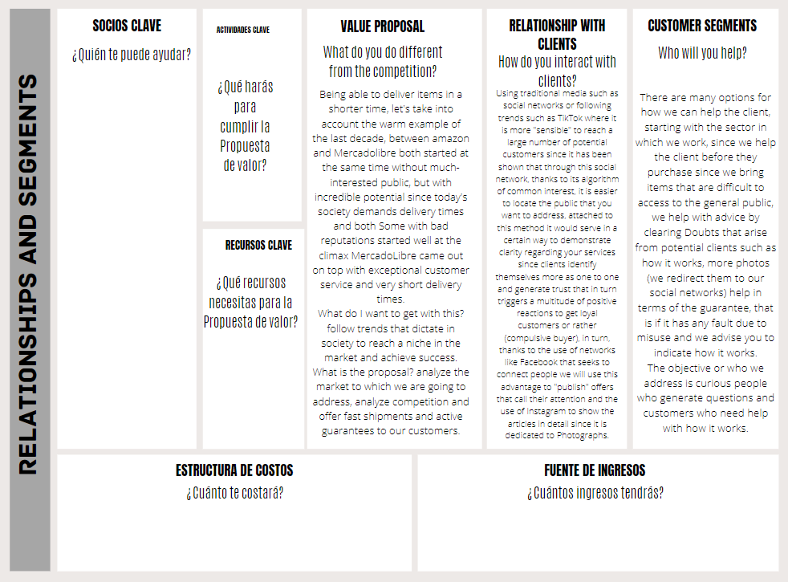-We fill in the requested fields and relocate the size of the text for a better representation.

# *Screenshots*

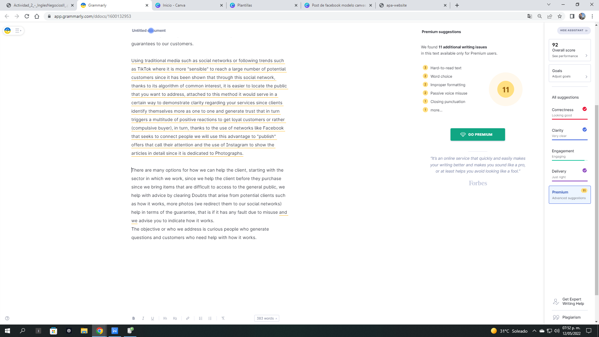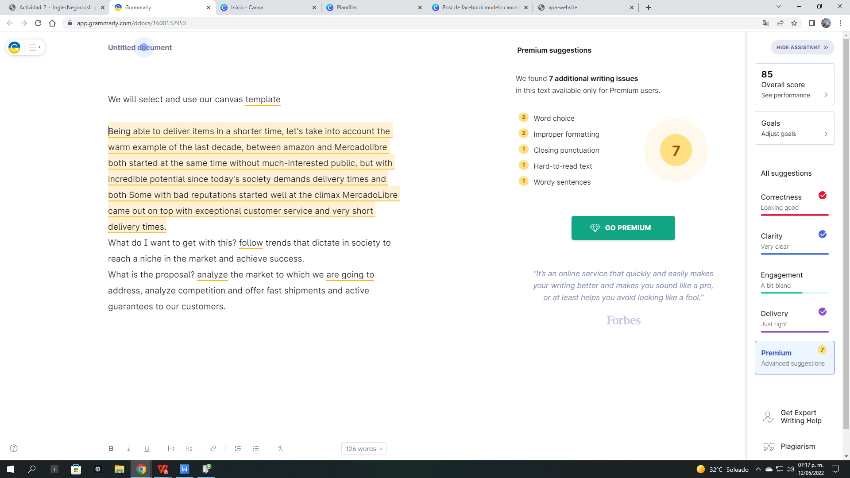

# ***Conclusion***

Communication is quite necessary to reach the level of trust in people without it we will not achieve anything, the media are quite helpful in transmitting what we want, and the approach we want to give is of the utmost importance since everything starts from here, that is to say, to answer some questions to know how we will achieve it, some of them are: What do we want to achieve? What public do we want to reach? What needs do we want to cover?

Achieving the greatest number of customers who, although they do not want to acquire our products or services, is our goal. Once we have their "attention" in a certain way, our job is to talk to them and generate that need to want to acquire it.

# *Bibliography*

Enrique Lopez. (2021). (opens in a new window) Facebook post model canvas for black and white formal business. 2022, by Private Website: <https://www.canva.com/p/templates/EAE7Ecp8BJs-post-de-facebook-model-canvas-for-business-formal-white-and-black/>